**PROGRAM:**

class PREDICATE:

def __str__(self):

pass

def __repr__(self):

pass

def __eq__(self, other) :

pass

def __hash__(self):

pass

def get_action(self, world_state):

pass

class Operation:

def __str__(self):

pass

def __repr__(self):

pass

def __eq__(self, other) :

pass

def precondition(self):

pass

def delete(self):

pass

def add(self):

pass

class ON(PREDICATE):

def __init__(self, X, Y):

self.X = X

self.Y = Y

def __str__(self):

return "ON({X},{Y})".format(X=self.X,Y=self.Y)

def __repr__(self):

return self.__str__()

def __eq__(self, other) :

return self.__dict__ == other.__dict__ and self.__class__ == other.__class__

def __hash__(self):

return hash(str(self))

def get_action(self, world_state):

return StackOp(self.X,self.Y)

class ONTABLE(PREDICATE):

def __init__(self, X):

self.X = X

def __str__(self):

return "ONTABLE({X})".format(X=self.X)

def __repr__(self):

return self.__str__()

def __eq__(self, other) :

return self.__dict__ == other.__dict__ and self.__class__ == other.__class__

def __hash__(self):

return hash(str(self))

def get_action(self, world_state):

return PutdownOp(self.X)

class CLEAR(PREDICATE):

def __init__(self, X):

self.X = X

def __str__(self):

return "CLEAR({X})".format(X=self.X)

self.X = X

def __repr__(self):

return self.__str__()

def __eq__(self, other) :

return self.__dict__ == other.__dict__ and self.__class__ == other.__class__

def __hash__(self):

return hash(str(self))

def get_action(self, world_state):

for predicate in world_state:

if isinstance(predicate,ON) and predicate.Y==self.X:

return UnstackOp(predicate.X, predicate.Y)

return None

class HOLDING(PREDICATE):

def __init__(self, X):

self.X = X

def __str__(self):

return "HOLDING({X})".format(X=self.X)

def __repr__(self):

return self.__str__()

def __eq__(self, other) :

return self.__dict__ == other.__dict__ and self.__class__ == other.__class__

def __hash__(self):

return hash(str(self))

def get_action(self, world_state):

X = self.X

if ONTABLE(X) in world_state:

return PickupOp(X)

else:

for predicate in world_state:

if isinstance(predicate,ON) and predicate.X==X:

return UnstackOp(X,predicate.Y)

class ARMEMPTY(PREDICATE):

def __init__(self):

pass

def __str__(self):

return "ARMEMPTY"

def __repr__(self):

return self.__str__()

def __eq__(self, other) :

return self.__dict__ == other.__dict__ and self.__class__ == other.__class__

def __hash__(self):

return hash(str(self))

def get_action(self, world_state=[]):

for predicate in world_state:

if isinstance(predicate,HOLDING):

return PutdownOp(predicate.X)

return None

class StackOp(Operation):

def __init__(self, X, Y):

self.X = X

self.Y = Y

def __str__(self):

return "STACK({X},{Y})".format(X=self.X,Y=self.Y)

def __repr__(self):

return self.__str__()

def __eq__(self, other) :

return self.__dict__ == other.__dict__ and self.__class__ == other.__class__

def precondition(self):

return [ CLEAR(self.Y) , HOLDING(self.X) ]

def delete(self):

return [ CLEAR(self.Y) , HOLDING(self.X) ]

def add(self):

return [ ARMEMPTY() , ON(self.X,self.Y) ]

class UnstackOp(Operation):

def __init__(self, X, Y):

self.X = X

self.Y = Y

def __str__(self):

return "UNSTACK({X},{Y})".format(X=self.X,Y=self.Y)

def __repr__(self):

return self.__str__()

def __eq__(self, other) :

return self.__dict__ == other.__dict__ and self.__class__ == other.__class__

def precondition(self):

return [ ARMEMPTY() , ON(self.X,self.Y) , CLEAR(self.X) ]

def delete(self):

return [ ARMEMPTY() , ON(self.X,self.Y) ]

def add(self):

return [ CLEAR(self.Y) , HOLDING(self.X) ]

class PickupOp(Operation):

def __init__(self, X):

self.X = X

def __str__(self):

return "PICKUP({X})".format(X=self.X)

def __repr__(self):

return self.__str__()

def __eq__(self, other) :

return self.__dict__ == other.__dict__ and self.__class__ == other.__class__

def precondition(self):

return [ CLEAR(self.X) , ONTABLE(self.X) , ARMEMPTY() ]

def delete(self):

return [ ARMEMPTY() , ONTABLE(self.X) ]

def add(self):

return [ HOLDING(self.X) ]

class PutdownOp(Operation):

def __init__(self, X):

self.X = X

def __str__(self):

return "PUTDOWN({X})".format(X=self.X)

def __repr__(self):

return self.__str__()

def __eq__(self, other) :

return self.__dict__ == other.__dict__ and self.__class__ == other.__class__

def precondition(self):

return [ HOLDING(self.X) ]

def delete(self):

return [ HOLDING(self.X) ]

def add(self):

return [ ARMEMPTY() , ONTABLE(self.X) ]

def isPredicate(obj):

predicates = [ON, ONTABLE, CLEAR, HOLDING, ARMEMPTY]

for predicate in predicates:

if isinstance(obj,predicate):

return True

return False

def isOperation(obj):

operations = [StackOp, UnstackOp, PickupOp, PutdownOp]

for operation in operations:

if isinstance(obj,operation):

return True

return False

def arm_status(world_state):

for predicate in world_state:

if isinstance(predicate, HOLDING):

return predicate

return ARMEMPTY()

class GoalStackPlanner:

def __init__(self, initial_state, goal_state):

self.initial_state = initial_state

self.goal_state = goal_state

def get_steps(self):

steps = []

stack = []

#World State/Knowledge Base

world_state = self.initial_state.copy()

#Initially push the goal_state as compound goal onto the stack

stack.append(self.goal_state.copy())

#Repeat until the stack is empty

while len(stack)!=0:

#Get the top of the stack

stack_top = stack[-1]

#If Stack Top is Compound Goal, push its unsatisfied goals onto stack

if type(stack_top) is list:

compound_goal = stack.pop()

for goal in compound_goal:

if goal not in world_state:

stack.append(goal)

elif isOperation(stack_top):

operation = stack[-1]

all_preconditions_satisfied = True

for predicate in operation.delete():

if predicate not in world_state:

all_preconditions_satisfied = False

stack.append(predicate)

if all_preconditions_satisfied:

stack.pop()

steps.append(operation)

for predicate in operation.delete():

world_state.remove(predicate)

for predicate in operation.add():

world_state.append(predicate)

elif stack_top in world_state:

stack.pop()

else:

unsatisfied_goal = stack.pop()

action = unsatisfied_goal.get_action(world_state)

stack.append(action)

for predicate in action.precondition():

if predicate not in world_state:

stack.append(predicate)

return steps

if __name__ == '__main__':

initial_state = [

ON('B','A'),ON('E', 'B'),

ONTABLE('A'),ONTABLE('C'),ONTABLE('D'),

CLEAR('B'),CLEAR('C'),CLEAR('D'),CLEAR('E'),

ARMEMPTY()

]

goal_state = [

ON('B','D'),ON('D','C'), ON('C', 'A'),ON('A', 'E'),

ONTABLE('A'),

CLEAR('B'),CLEAR('C'), CLEAR('D'),CLEAR('E'),

ARMEMPTY()

]

goal_stack = GoalStackPlanner(initial_state=initial_state, goal_state=goal_state)

steps = goal_stack.get_steps()

print("UNSTACK(E,B)")

print("PUTDOWN(E)")

for i in steps:

print(i)

**OUTPUT:**

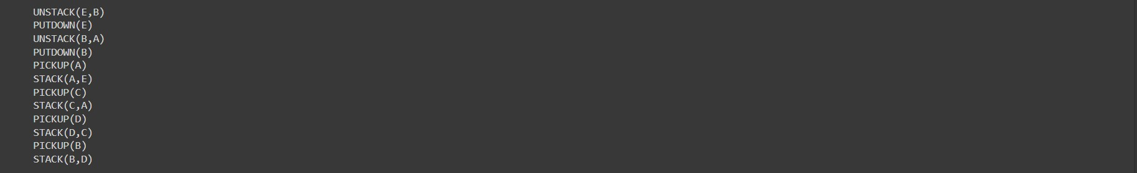

**PROGRAM:**

import numpy as np

import pandas as pd

from sklearn.model_selection import train_test_split

from sklearn.tree import DecisionTreeClassifier

from sklearn.metrics import accuracy_score

def splitdataset(balance_data):

X = balance_data.values[:, 1:5]

Y = balance_data.values[:, 0]

X_train, X_test, y_train, y_test = train_test_split(

X, Y, test_size = 0.3, random_state = 100)

return X, Y, X_train, X_test, y_train, y_test

def prediction(X_test, clf_object):

y_pred = clf_object.predict(X_test)

print("Predicted values:")

print(y_pred)

return y_pred

if __name__=="__main__":

data = pd.read_csv('https://archive.ics.uci.edu/ml/machine-learning-databases/balance-scale/balance-scale.data', sep= ',', header = None)

X = data.values[:, 1:5]

Y = data.values[:, 0]

X_train, X_test, y_train, y_test = train_test_split(X, Y, test_size = 0.3, random_state = 100)

clf_entropy = DecisionTreeClassifier(criterion = "entropy", random_state = 100,max_depth = 3, min_samples_leaf = 5)

clf_entropy.fit(X_train, y_train)

y_pred = prediction(X_test, clf_entropy)

print("Accuracy : ", accuracy_score(y_test,y_pred)*100)

**OUTPUT:**

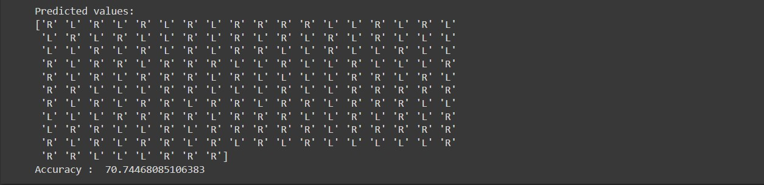

**PROGRAM:**

**# Bagged Decision Trees for Classificationfrom inspect import Traceback**

from pandas import read_csv

from sklearn.model_selection import KFold

from sklearn.model_selection import cross_val_score

from sklearn.ensemble import BaggingClassifier

from sklearn.tree import DecisionTreeClassifier

path="/content/pima-indians-diabetes.csv"

headernames = ['preg', 'plas', 'pres', 'skin', 'test', 'mass', 'pedi', 'age', 'class']

data = read_csv(path, names=headernames)

array = data.values

X = array[:,0:8]

Y = array[:,8]

seed = 7

kfold = KFold(n_splits = 10,random_state=seed,shuffle=True)

cart = DecisionTreeClassifier()

num_trees = 150

model = BaggingClassifier(base_estimator = cart, n_estimators = num_trees, random_state = seed)

results = cross_val_score(model, X, Y, cv=kfold)

print(results.mean())

**# Random Forest Classification**

import pandas

from sklearn import model_selection

from sklearn.ensemble import RandomForestClassifier

url = "/content/pima-indians-diabetes.csv"

names = ['preg', 'plas', 'pres', 'skin', 'test', 'mass', 'pedi', 'age', 'class']

dataframe = pandas.read_csv(url, names=names)

array = dataframe.values

X = array[:,0:8]

Y = array[:,8]

seed = 7

num_trees = 100

max_features = 3

kfold = model_selection.KFold(n_splits=10, random_state=seed,shuffle=True)

model = RandomForestClassifier(n_estimators=num_trees, max_features=max_features)

results = model_selection.cross_val_score(model, X, Y, cv=kfold)

print(results.mean())

**# Extra Trees Classification**

import pandas

from sklearn import model_selection

from sklearn.ensemble import ExtraTreesClassifier

url = "/content/pima-indians-diabetes.csv"

names = ['preg', 'plas', 'pres', 'skin', 'test', 'mass', 'pedi', 'age', 'class']

dataframe = pandas.read_csv(url, names=names)

array = dataframe.values

X = array[:,0:8]

Y = array[:,8]

seed = 7

num_trees = 100

max_features = 7

kfold = model_selection.KFold(n_splits=10, random_state=seed,shuffle=True)

model = ExtraTreesClassifier(n_estimators=num_trees, max_features=max_features)

results = model_selection.cross_val_score(model, X, Y, cv=kfold)

print(results.mean())

**# AdaBoost Classification**

import pandas

from sklearn import model_selection

from sklearn.ensemble import AdaBoostClassifier

url = "/content/pima-indians-diabetes.csv"

names = ['preg', 'plas', 'pres', 'skin', 'test', 'mass', 'pedi', 'age', 'class']

dataframe = pandas.read_csv(url, names=names)

array = dataframe.values

X = array[:,0:8]

Y = array[:,8]

seed = 7

num_trees = 30

kfold = model_selection.KFold(n_splits=10, random_state=seed,shuffle=True)

model = AdaBoostClassifier(n_estimators=num_trees, random_state=seed)

results = model_selection.cross_val_score(model, X, Y, cv=kfold)

print(results.mean())

**# Stochastic Gradient Boosting Classification**

import pandas

from sklearn import model_selection

from sklearn.ensemble import GradientBoostingClassifier

url = "/content/pima-indians-diabetes.csv"

names = ['preg', 'plas', 'pres', 'skin', 'test', 'mass', 'pedi', 'age', 'class']

dataframe = pandas.read_csv(url, names=names)

array = dataframe.values

X = array[:,0:8]

Y = array[:,8]

seed = 7

num_trees = 100

kfold = model_selection.KFold(n_splits=10, random_state=seed,shuffle=True)

model = GradientBoostingClassifier(n_estimators=num_trees, random_state=seed)

results = model_selection.cross_val_score(model, X, Y, cv=kfold)

print(results.mean())

**# Voting Ensemble for Classification**

import pandas

from sklearn import model_selection

from sklearn.linear_model import LogisticRegression

from sklearn.tree import DecisionTreeClassifier

from sklearn.svm import SVC

from sklearn.ensemble import VotingClassifier

url = "/content/pima-indians-diabetes.csv"

names = ['preg', 'plas', 'pres', 'skin', 'test', 'mass', 'pedi', 'age', 'class']

dataframe = pandas.read_csv(url, names=names)

array = dataframe.values

X = array[:,0:8]

Y = array[:,8]

seed = 7

kfold = model_selection.KFold(n_splits=10, random_state=seed,shuffle=True)

# create the sub models

estimators = []

model1 = LogisticRegression()

estimators.append(('logistic', model1))

model2 = DecisionTreeClassifier()

estimators.append(('cart', model2))

model3 = SVC()

estimators.append(('svm', model3))

# create the ensemble model

ensemble = VotingClassifier(estimators)

results = model_selection.cross_val_score(ensemble, X, Y, cv=kfold)

print(results.mean())

**OUTPUT:**











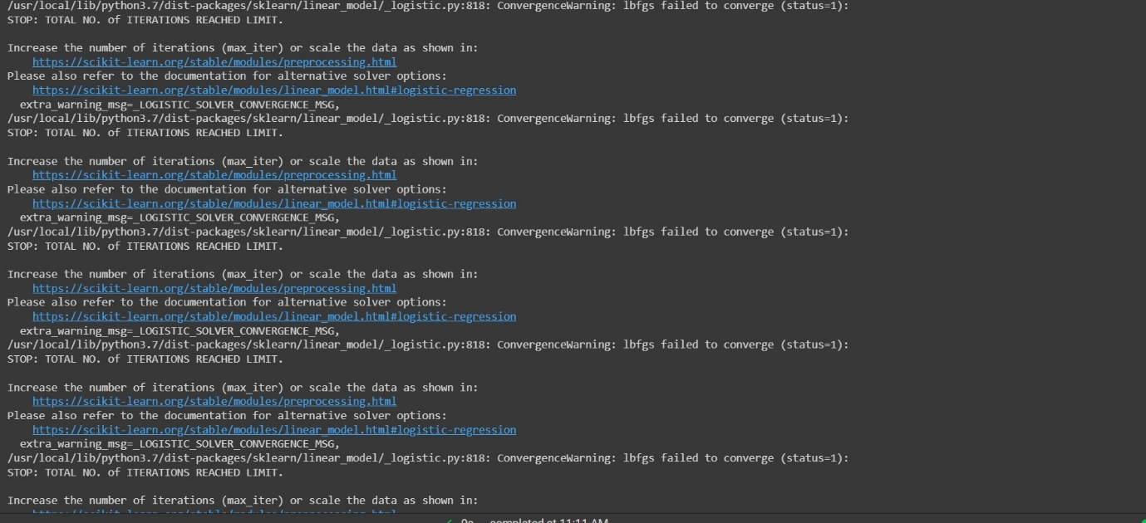

**PROGRAM:**

# Load libraries

from sklearn.ensemble import AdaBoostClassifier

from sklearn import datasets

# Import train_test_split function

from sklearn.model_selection import train_test_split

#Import scikit-learn metrics module for accuracy calculation

from sklearn import metrics

# Load data

iris = datasets.load_iris()

X = iris.data

y = iris.target

# Split dataset into training set and test set

X_train, X_test, y_train, y_test = train_test_split(X, y, test_size=0.3) # 70% training and 30%

# Create adaboost classifer object

abc = AdaBoostClassifier(n_estimators=50,

learning_rate=1)

# Train Adaboost Classifer

model = abc.fit(X_train, y_train)

#Predict the response for test dataset

y_pred = model.predict(X_test)

# Model Accuracy, how often is the classifier correct?

print("Accuracy:",metrics.accuracy_score(y_test, y_pred))

**OUTPUT:**



**PROGRAM:**

**Sentiment Analysis**

import pandas as pd

import nltk

from nltk.sentiment.vader import SentimentIntensityAnalyzer

nltk.download('all')

# reading and wragling data

df_avatar = pd.read_csv('avatar.csv', encoding = 'unicode_escape', engine='python')

df_avatar_lines = df_avatar.groupby('character').count()

df_avatar_lines = df_avatar_lines.sort_values(by=['character_words'], ascending=False)[:10]

top_character_names = df_avatar_lines.index.values

# filtering out non-top characters

df_character_sentiment = df_avatar[df_avatar['character'].isin(top_character_names)]

df_character_sentiment = df_character_sentiment[['character', 'character_words']]

# calculating sentiment score

sid = SentimentIntensityAnalyzer()

df_character_sentiment.reset_index(inplace=True, drop=True)

df_character_sentiment[['neg', 'neu', 'pos', 'compound']] = df_character_sentiment['character_words'].apply(sid.polarity_scores).apply(pd.Series)

df_character_sentiment

## **Plotting sentiment**

import matplotlib.pyplot as plt

import numpy as np

# preparing data

X = np.arange(len(df_character_sentiment['pos']))

#bar plot

fig = plt.figure(figsize = (17, 12))

plt.barh(X, df_character_sentiment['pos'], facecolor='#9999ff', edgecolor='white')

plt.barh(X, -df_character_sentiment['neg'], facecolor='#ff9999', edgecolor='white')

# plt.rcParams.update({'font.size':13})

plt.xlim([-.16,.22])

plt.yticks(ticks=X, labels=df_character_sentiment['character'], rotation='0')

plt.show()

# Named Entity Recognition (NER)

# import spacy

# nlp = spacy.load("en_core_web_sm")

# doc = nlp("Biden invites Ukrainian president to White House this summer")

# print([(X.text, X.label_) for X in doc.ents])

**Stemming**

from nltk.stem import PorterStemmer

from nltk.stem import LancasterStemmer

# PorterStemmer

porter = PorterStemmer()

# LancasterStemmer

lancaster = LancasterStemmer()

print(porter.stem("friendship"))

print(lancaster.stem("friendship"))

# Lemmatization

# from nltk import WordNetLemmatizer

# lemmatizer = WordNetLemmatizer()

# words = ['articles', 'friendship', 'studies', 'phones']

# for word in words:

# print(lemmatizer.lemmatize(word))

# from nltk import WordNetLemmatizer

# lemmatizer = WordNetLemmatizer()

# words = ['be', 'is', 'are', 'were', 'was']

# for word in words:

# print(lemmatizer.lemmatize(word, pos='v'))

# Bag of Words (BoW)

# import pandas as pd

# from sklearn.feature_extraction.text import CountVectorizer

# text = ["I love writing code in Python. I love Python code",

# "I hate writing code in Java. I hate Java code"]

# df = pd.DataFrame({'review': ['review1', 'review2'], 'text':text})

# cv = CountVectorizer(stop_words='english')

# cv_matrix = cv.fit_transform(df['text'])

# df_dtm = pd.DataFrame(cv_matrix.toarray(),

# index=df['review'].values,

# columns=cv.get_feature_names())

# df_dtm

# TF-IDF

# import pandas as pd

# from sklearn.feature_extraction.text import TfidfVectorizer

# text = ["I love writing code in Python. I love Python code",

# "I hate writing code in Java. I hate Java code"]

# df = pd.DataFrame({'review': ['review1', 'review2'], 'text':text})

# tfidf = TfidfVectorizer(stop_words='english', norm=None)

# tfidf_matrix = tfidf.fit_transform(df['text'])

# df_dtm = pd.DataFrame(tfidf_matrix.toarray(),

# index=df['review'].values,

# columns=tfidf.get_feature_names())

# df_dtm

**OUTPUT**

